**Exercise 1: Control Structures**

**Scenario 1:** The bank wants to apply a discount to loan interest rates for customers above 60 years old.

* + **Question:** Write a PL/SQL block that loops through all customers, checks their age, and if they are above 60, apply a 1% discount to their current loan interest rates.

**CODE:**

BEGIN

  FOR cust IN (SELECT * FROM customers) LOOP

    IF cust.age > 60 THEN

      UPDATE loans

      SET interest_rate = interest_rate - 1

      WHERE customer_id = cust.customer_id;

      DBMS_OUTPUT.PUT_LINE('Applied 1% discount to customer ' || cust.name);

    END IF;

  END LOOP;

  COMMIT;

END;

**OUTPUT:**

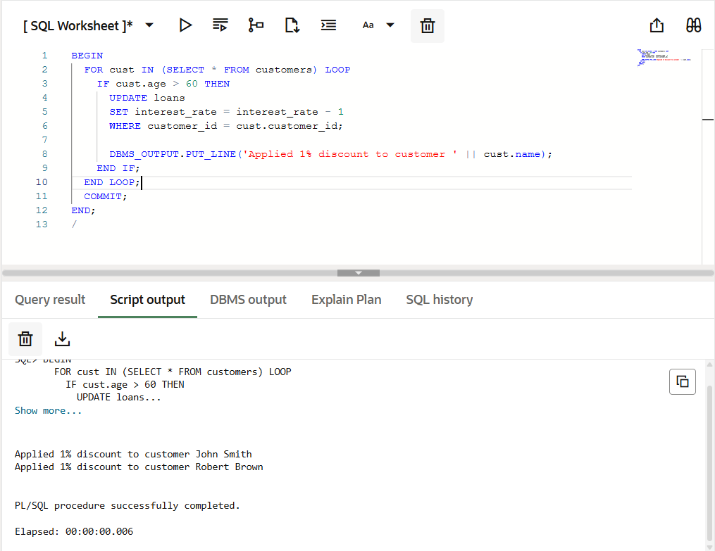

**Scenario 2:** A customer can be promoted to VIP status based on their balance.

* + **Question:** Write a PL/SQL block that iterates through all customers and sets a flag IsVIP to TRUE for those with a balance over $10,000.

**CODE:**

BEGIN

FOR cust IN (SELECT * FROM customers WHERE balance > 10000) LOOP

UPDATE customers

SET is_vip = 'TRUE'

WHERE customer_id = cust.customer_id;

DBMS_OUTPUT.PUT_LINE('Promoted to VIP: ' || cust.name);

END LOOP;

COMMIT;

END;

**OUTPUT:**

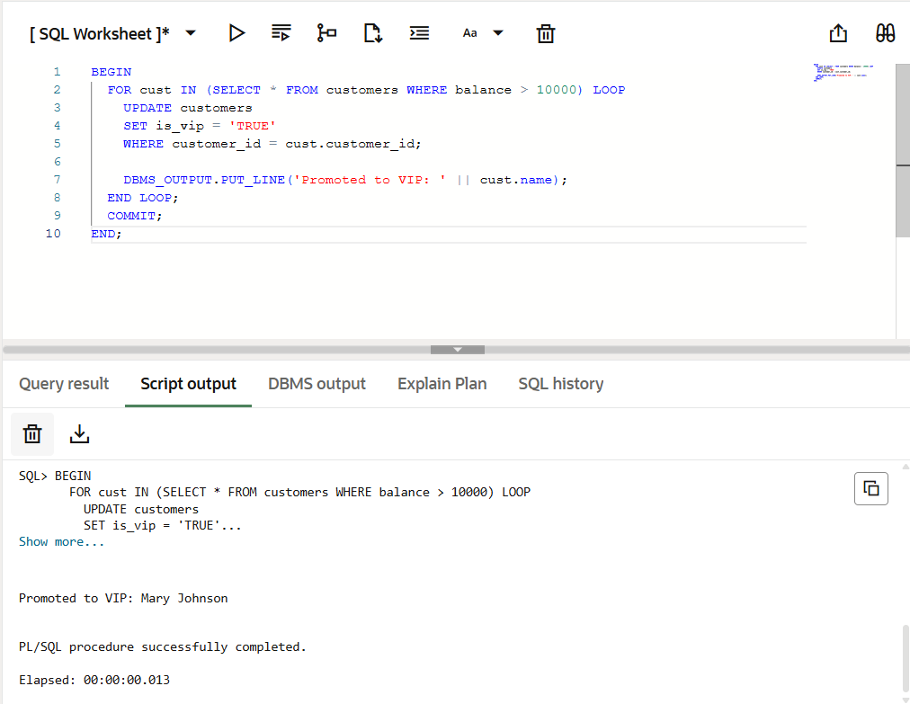

**Scenario 3:** The bank wants to send reminders to customers whose loans are due within the next 30 days.

* + **Question:** Write a PL/SQL block that fetches all loans due in the next 30 days and prints a reminder message for each customer.

**CODE:**

BEGIN

FOR loan_rec IN (

SELECT l.loan_id, c.name, c.customer_id, l.due_date

FROM loans l JOIN customers c ON l.customer_id = c.customer_id

WHERE l.due_date BETWEEN SYSDATE AND SYSDATE+30) LOOP

DBMS_OUTPUT.PUT_LINE('REMINDER: ' || loan_rec.name ||

', your loan #' || loan_rec.loan_id ||

' is due on ' || TO_CHAR(loan_rec.due_date, 'DD-MON-YYYY'));

UPDATE customers

SET last_reminder_date = SYSDATE

WHERE customer_id = loan_rec.customer_id;

END LOOP;

COMMIT;

END;

**OUTPUT:**

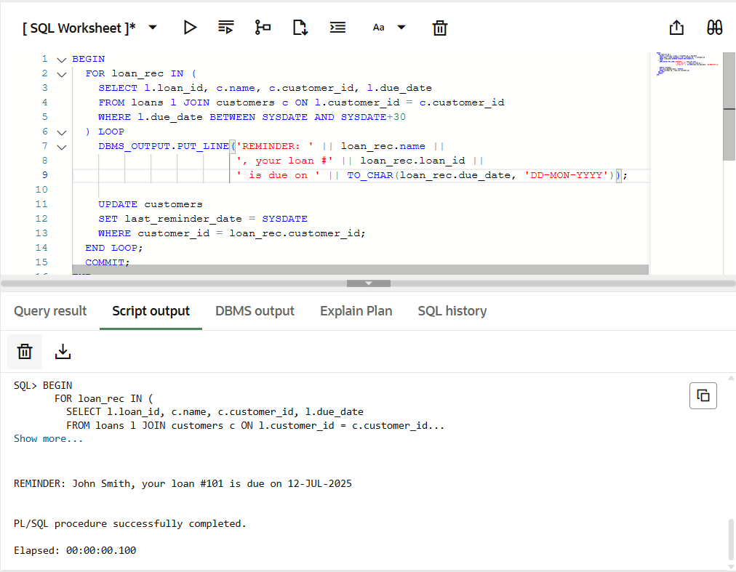

**Exercise 3: Stored Procedures**

**Scenario 1:** The bank needs to process monthly interest for all savings accounts.

* + **Question:** Write a stored procedure **ProcessMonthlyInterest** that calculates and updates the balance of all savings accounts by applying an interest rate of 1% to the current balance.

**Scenario 2:** The bank wants to implement a bonus scheme for employees based on their performance.

* + **Question:** Write a stored procedure **UpdateEmployeeBonus** that updates the salary of employees in a given department by adding a bonus percentage passed as a parameter.

**Scenario 3:** Customers should be able to transfer funds between their accounts.

* + **Question:** Write a stored procedure **TransferFunds** that transfers a specified amount from one account to another, checking that the source account has sufficient balance before making the transfer.

**Exercise 4: Functions**

**Scenario 1:** Calculate the age of customers for eligibility checks.

* + **Question:** Write a function CalculateAge that takes a customer's date of birth as input and returns their age in years.

**Scenario 2:** The bank needs to compute the monthly installment for a loan.

* + **Question:** Write a function **CalculateMonthlyInstallment** that takes the loan amount, interest rate, and loan duration in years as input and returns the monthly installment amount.

**Scenario 3:** Check if a customer has sufficient balance before making a transaction.

* + **Question:** Write a function **HasSufficientBalance** that takes an account ID and an amount as input and returns a boolean indicating whether the account has at least the specified amount.

**Exercise 5: Triggers**

**Scenario 1:** Automatically update the last modified date when a customer's record is updated.

* + **Question:** Write a trigger **UpdateCustomerLastModified** that updates the LastModified column of the Customers table to the current date whenever a customer's record is updated.

**Scenario 2:** Maintain an audit log for all transactions.

* + **Question:** Write a trigger **LogTransaction** that inserts a record into an AuditLog table whenever a transaction is inserted into the Transactions table.

**Scenario 3:** Enforce business rules on deposits and withdrawals.

* + **Question:** Write a trigger **CheckTransactionRules** that ensures withdrawals do not exceed the balance and deposits are positive before inserting a record into the Transactions table.

**Exercise 6: Cursors**

**Scenario 1:** Generate monthly statements for all customers.

* + **Question:** Write a PL/SQL block using an explicit cursor **GenerateMonthlyStatements** that retrieves all transactions for the current month and prints a statement for each customer.

**Scenario 2:** Apply annual fee to all accounts.

* + **Question:** Write a PL/SQL block using an explicit cursor **ApplyAnnualFee** that deducts an annual maintenance fee from the balance of all accounts.

**Scenario 3:** Update the interest rate for all loans based on a new policy.

* + **Question:** Write a PL/SQL block using an explicit cursor **UpdateLoanInterestRates** that fetches all loans and updates their interest rates based on the new policy.

**Exercise 7: Packages**

**Scenario 1:** Group all customer-related procedures and functions into a package.

* + **Question:** Create a package **CustomerManagement** with procedures for adding a new customer, updating customer details, and a function to get customer balance.

**Scenario 2:** Create a package to manage employee data.

* + **Question:** Write a package **EmployeeManagement** with procedures to hire new employees, update employee details, and a function to calculate annual salary.

**Scenario 3:** Group all account-related operations into a package.

* + **Question:** Create a package **AccountOperations** with procedures for opening a new account, closing an account, and a function to get the total balance of a customer across all accounts.

**Schema to be Created**

*CREATE TABLE Customers (*

*CustomerID NUMBER PRIMARY KEY,*

*Name VARCHAR2(100),*

*DOB DATE,*

*Balance NUMBER,*

*LastModified DATE*

*);*

*CREATE TABLE Accounts (*

*AccountID NUMBER PRIMARY KEY,*

*CustomerID NUMBER,*

*AccountType VARCHAR2(20),*

*Balance NUMBER,*

*LastModified DATE,*

*FOREIGN KEY (CustomerID) REFERENCES Customers(CustomerID)*

*);*

*CREATE TABLE Transactions (*

*TransactionID NUMBER PRIMARY KEY,*

*AccountID NUMBER,*

*TransactionDate DATE,*

*Amount NUMBER,*

*TransactionType VARCHAR2(10),*

*FOREIGN KEY (AccountID) REFERENCES Accounts(AccountID)*

*);*

*CREATE TABLE Loans (*

*LoanID NUMBER PRIMARY KEY,*

*CustomerID NUMBER,*

*LoanAmount NUMBER,*

*InterestRate NUMBER,*

*StartDate DATE,*

*EndDate DATE,*

*FOREIGN KEY (CustomerID) REFERENCES Customers(CustomerID)*

*);*

*CREATE TABLE Employees (*

*EmployeeID NUMBER PRIMARY KEY,*

*Name VARCHAR2(100),*

*Position VARCHAR2(50),*

*Salary NUMBER,*

*Department VARCHAR2(50),*

*HireDate DATE*

*);*

**Example Scripts for Sample Data Insertion**

*INSERT INTO Customers (CustomerID, Name, DOB, Balance, LastModified)*

*VALUES (1, 'John Doe', TO_DATE('1985-05-15', 'YYYY-MM-DD'), 1000, SYSDATE);*

*INSERT INTO Customers (CustomerID, Name, DOB, Balance, LastModified)*

*VALUES (2, 'Jane Smith', TO_DATE('1990-07-20', 'YYYY-MM-DD'), 1500, SYSDATE);*

*INSERT INTO Accounts (AccountID, CustomerID, AccountType, Balance, LastModified)*

*VALUES (1, 1, 'Savings', 1000, SYSDATE);*

*INSERT INTO Accounts (AccountID, CustomerID, AccountType, Balance, LastModified)*

*VALUES (2, 2, 'Checking', 1500, SYSDATE);*

*INSERT INTO Transactions (TransactionID, AccountID, TransactionDate, Amount, TransactionType)*

*VALUES (1, 1, SYSDATE, 200, 'Deposit');*

*INSERT INTO Transactions (TransactionID, AccountID, TransactionDate, Amount, TransactionType)*

*VALUES (2, 2, SYSDATE, 300, 'Withdrawal');*

*INSERT INTO Loans (LoanID, CustomerID, LoanAmount, InterestRate, StartDate, EndDate)*

*VALUES (1, 1, 5000, 5, SYSDATE, ADD_MONTHS(SYSDATE, 60));*

*INSERT INTO Employees (EmployeeID, Name, Position, Salary, Department, HireDate)*

*VALUES (1, 'Alice Johnson', 'Manager', 70000, 'HR', TO_DATE('2015-06-15', 'YYYY-MM-DD'));*

*INSERT INTO Employees (EmployeeID, Name, Position, Salary, Department, HireDate)*

*VALUES (2, 'Bob Brown', 'Developer', 60000, 'IT', TO_DATE('2017-03-20', 'YYYY-MM-DD'));*